Author: Smaranda-Sabina Moldovan,
Assistant professor at West University, Faculty of Arts and Design,
Email: smaranda.moldovan@e-uvt.ro

Interconnections of objects in contemporary art

Abstract
The article is part of my research on the painting practices in the contemporary art scene. The title might raise questions about the term of objects(”objects”/objects that are) related to the painting area, first because of its vague connotation field and after (second) because painting is known as a bidimensional medium. The term object desires more attention and has a wide meaning generally. The term object has a wide meaning and desires more attention.Regarding this text, the word object refers to the recipient that contains signs and values of our everyday life.
The phenomenon of consumption is characterized by a series of human relations with the object. These relationships are related to factors such as: its usefulness, its collection(value?), decorative function, aesthetic function, possessiveness and constant need to purchase. In this article, the object will not be usednot to define the development of aggressive advertising of our days, but to underline the interdisciplinary and transdisciplinary (aspect of?) contemporary art phenomena. The term variation is in no way used pejoratively here, but simply as an artistic and philosophical marker and descriptor. This transmission of ideas and artistic practices through the object are wide in the field of modern art. Many terms such as: object painting, assemblage,or simply named three dimensional works define a blending between the mediums ofvisual arts mediumswith the(and the) philosophical theories of the object from Platon to Sorensen and socially engaged artistic practices, leaving a trace of ambiguity. Our topic for this article is to bring a small amount of definitions to what can be considered an object painting in the visual art field today. It allows to enlarge the sphere of artworks in art history, artworks that are dynamic and in a close interaction with the changes in the environment and(or in/or) social and political context.
Keywords: #objectpainting, #monochrome, #colourfield, #blue, #abstractpainting, #arttheory, #contemporaryart, #neodada, #philosphy, #ontology.(aliniere stânga)

Introduction
The definition of the term object according to the Cambridge Dictionary is „a material thing that can be seen and touched.” Philosopher Alfred Jules Ayer (Ayers 2005), in his early work defines the philosophical object as a material object that has the ability to form a relation between actual and possible sensory (experienced by senses) data. So, according to the english philosopher, who was inspired by David Hume and Bertand Russel (Marek 2021), we understandany kind of object, including the physical object, by our sensorial experience. The object, according to the empiricism of David Hume has the property of existence, no matter where there is physical or just the idea of an object. Instead, for the german philosopher Bernard Russel (Russel 2004), the object itself is just a mixture of properties, defining them after a description of characteristics. So, the russelian mermaid can be a mythological creature, a woman with a fish tail.(punctat mai clar exemplul)
In contrast with Bernard Russel’s theory, Alexius Meinong (Marek 2021) comes to(is classifying/classifies)classify the object in three categories. The (this?) classification, made from a phenomenological point of view, contains three classes of objects: real objects or so called physical objects, non-existing objects that are ideas, numbers or theoremes, and the impossible objects class on which he makes(gives the squarecircle as an example?) an example a squarecircle. The class of impossible objects includes the class of objects that cannot exist, which in turn includes the class of objects themselves. Thus, according to the theory of the Austrian philosopher, all objects have the characteristic of being impossible.
Turning back in timeThe object, from an artistic and philosophical point of view, can be identified in the ancient works, starting with Plato, who analyzed the world of forms. The object can be anything, something, a content, on which human reason turns its gaze.
The idealism (idealistic?) and naturalistic perspective that Plato shaped, makes a clear distinction between the world of forms and (the world of)ideas. According to the greek philosopher the(this?) worlds are related but do not have the same value. The world of ideas, is a world that is primordial and perpetual, in contrast with the material world. The objects are contained into the tangible world and they are nothing more than copies of the idea-objects from the unalterable world. The material world is defined by a permanent dynamic. (nu are continuare, mai trebuie o definitie a lumii nealterabile)
During the same ancient period(se știe) Aristotel (Aristotel 2007) questions the material world and the objects by their own existence(Aristotel 2007). Among Aristotel, Plotin writes his essays on beauty, the enneade, that are relevant for the visual art domain.
Ontology as a definition is sometimes considered to be the theory of objects. As can be seen from the information gathered previously, the term object is debatable. This paper aims to deepen the semantic and semiotic field of the object, which makes it necessary to introduce theories related to the ontological object. The ontological object can designate a cavity, a hole -like those (found?)in the cheese -evoked as a premise in the article Holes by Stephanie and David Lewis (Lewis and Lewis 2006). Thus, an occult material is integrated in each object, and the hole that occurs, its shape, is an object itself.Being three-dimensional, it can be measured, it can be counted, it can be formed, it disappears and it can be transformed or changed. Holes can unify. The dialogue between the two authors turns out to be a nominalist, counter-realism(de reformulat), in which the presence or absence of an object in the(like the?/such as the?) case of a hole, or an empty space in an object such as a roll of toilet paper is debated. Following the dialogue, several hypotheses are foreshadowed: there are no immaterial or abstract objects, the holes exist, and these can be immaterial objects or objects whose matter does not exist. Missing objects. If the holes did not exist, it would not be correct to say that the cheese has holes, but only that the cheese is perforated.
According to Stephen Gross (Gross 1994, 1), the philosophers Casati and Varzi define holes as being made of space, of the vacuum, like the actual objects in matter. This delimited space with a specific location consists of immaterial matter. Holes are something, they are objects dependent on the host material only under certain conditions: the host material of the object must contain convex or concave concavities, such as Henry Moore's sculptures. This type of object raises problems when immersing in other liquids and filling cavities with matter itself or through the gears of objects containing holes or spaces between the component objects. They do not have the power to cause anything, but only exist as the anti-objects mentioned by JosephBeuys (Harlan 2003). A possible solution may come from the memory of objects and the elimination of the temporal axis, as exemplified by certain dislocated monuments, but which continue to exist in the collective memory of the place.
Barry Smith (Smith 2001, 131–148), American philosopher, recently classifies objects into incomplete type categories and introduces the concept of object boundary. He places the limit emphasis on actual entities, such as the border of a country or aregion, those that are born through contact with an object, such as alliances or countries that have ceased to exist. This relationship of the object born by contact can be identified in the human figures of Magda Cordell who are subject to the external influences of the social objects themselves.
The artistic object, as I will delve into this manuscript, is a material form that exists independently of its retainers. It can be purely physical as an object trouvee, composed in the same way as the actual objects in assemblies (Lugli 2000) or only documentary, as in conceptual art, thus existing only at the level of project or document as in the works of Sol LeWitt (LeWitt 1967).
The metaphysical objects from previous studies have echoes in modern visual arts such as dadaism. The premise of Dada movement can be layered on the structure of absent objects, because the Dadaists wanted to devalue the traditional literature and visual arts by destroying the compositional structures, the theories of color harmonies. Collage and takeoff appear. Breaking the glued pieces creates holes like the ones illustrated by David and Stephanie Lewis.
There are also clothing items such as the costume worn by Hugo Ball in the Karawane performance on the stage of the Voltaire cabaret, the costume being the creation of the artist Marcel Janco. The costume is composed of materials with which we interact every day such as cardboard tubes colored in blue and gold, objects proper in conservative vision. It has a compositional structure reminiscent of Russian constructivism or futurism. Hugo Ball, in his recitation of the performance(care performance?), uses sounds in an absurd way, theySounds arebeing separated, thus remaining meaningless, like objects classified by Franz Brentano (Brentano 1973) as imaginary, annihilating and creating at the same time, they are codependent by the transmitter. In the recitals that will follow, he will use superimposed poetry, where the sounds will overlap, aiming to induce confusion. We identify the objects around us by a name, and within the Dadaist performance it disappears, the phonetics being purely random. We can only assume that some random sounds might be called objects.(vezi Plinul, respectiv Solidul (care există) și Golul, respectiv Rarul (care nu există), identificate cu Ființa și Neființala Leucip si Democrit”De aceea și spun ei că Neființa există tot așa de bine ca Ființa, precum și Golul tot așa de bine ca și ceea ce are un Corp, și după ei, acestea sunt cauzele Universului considerat doar ca materie”- Aristotel – Metafizica – Cartea I, p 28 - citatul din Aristotel il folosesc eu intr-un eseu... sorry.)
In return to the Marcel Junco`s tridimensional assemblage costume, collage is used on a bidimensional surface by Hans Arp to destroy the myth of the genius artist, bringing his works as far as possible to a stage of impersonality. The works of Hans Arp in the Collage Arranged According to the Laws of Chance, series of 1917, propose the intervention of chance by the simple fact that Arp released from the height some colored cardboards on a flat surface. The resulting configuration was the basis of the compositional structure. Later, Hans Arp intervened by ordering them, so that they almost did not touch. There is a contrast between order and disorder starting from the principle of chance.
In 1918, Raoul Hausmann published Synthetic Cino of Painting, a manifesto in which he proposed new materials for painting, as well as actual fragments from the real world: photographs, pieces from newspapers and magazines, objects from everyday life. He believes that they are much more suitable for rendering reality than the technique of oil painting. In 1920 he proposed two photomontages: Tatlin Lives at Home and The Art Critic.
Returning to Ayers`s Theory about sensorial data, it emerged that when children grow they typically develop the refined ability to appropriately index, harmonize, and distinguish sensory information from objects to reinforce the range of effective emotion adjustment, social adroitness, play ability, and fine motor and gross motor capability (therapy used after Ayers is named Sensory Integration). A similar type of occurrence can be evidenced also in understanding modern and contemporary art. The mechanisms that we use in perceiving contemporary art are developed by our sensory data. This data thatWe collect this data from our interaction with art pieces from museums, galleries and private collections from all over the world in a certain period of time. The object of the study will try to elucidate more to a public that is intimate with traditional art, friendly with modern art and has to engage in developing a participation in the social context of the intermingling objects of contemporary art.

Methods
Methods of research that are used are also mixed. Predominant is the art based research, followed by technical experiment and secondary data and formal analysis (iconology and iconography). The modus operandi is utterly empirical, descriptive and based on two study cases.
The first case deems the traditional painting and the second case the object painting, or the assemblage painting. The connection between the two cases is the quasi-experimental method of unification by colour. The homochromous approach has a wide range of action in art history, starting from petroglyphs and petrographs in Neolithic and Upper Paleolithic with intermissions in time in Antiquity, Middle Ages, Renaissance, until the modern art. Experiments like this have roots in the work of modern artists that produced art under the name of constructivism, minimalism and nouveau realisme such as Kazimir Malevici, Pierre Soulages, Yves Klein, Piero Manzoni, Pino Pascali.
The (this?) cases presented in the study are part of the experimental research. The case studies are viewed also from a point of view that leads to a causal-comparative formula in Fine Art Theory and Educational Research. The first case is based on the art work that I have done during the art symposium in 2019, in Arkabaat, province of Trabzon, Turkey, Untitled, 140/100 cm, for the collection of the future art museum of the city. The second study case is an assemblage made during the first year of pandemy, named Covidie or Object n.ro 43, mixed media, 2020. Both cases will have their own section for discussion and results included.
Untitled, 2019, oil on canvas. Collection of Arkabaat Municipality.
This work is done in a traditional painting technique. It will be studied both from an iconographic perspective, as anor?iconologic point of view. It is related to the art symposia from Turkey in August 2019, and the particular place,where I have been. It is an otoman area that is located on the edge of Black Sea, with ancient persian origins, roman and russian influences. The element that has influenced the concept of the painting is the topography of the land that, within 16 km,contains very significant variations in elevation, approx. 1200 m. The passage from seaside to the mountain happens so fast and creates a particular sensation. Weather also is a quick changing element, with sun and rain and storm due to the geography of the province. According to the definition of the philosophical object, I consider the place an object, maybe a composed object, a monade that is open and communicates with other objects as(like/such as) the sea, the elements of weather such as rain and clouds. The energy of the place(prea poetic...) had an impact on the structure of the canvas. It has, as the topography of the land, its flows, ups and downs. The rhythm of this feeling is translated in the iconographic layer of the painting by its compositional structure based on a movement that goes in a much deeper dynamic in the lower part. In the upper part it remains a sort of incomputo, a layer of grisailles of the skies in my five days of observing the world there. It also has lower blue additions in it showing how the first layers of the painting were made and the transition to the blue surface that covers more than 70% of the painting. The blue has highly influences from the work of Yves Klein And Pierre Soulages (early works), but with several distinctions. The blue in my work suffered a degradation on the value scale because the point of the blue was not to be itself the protagonist but the element that unifies the objects from that time in place with other works I have done previously and after. The blue is infected(prea poetic) with the black from the black sand from(found on?) the seashore of the Black Sea and with the grey of the heavy clouds.thatIf you would go in the mountains plato, like Hidirnebi, you would be just inside them(de reformulat... prea subiectiv). A more stable(clear/direct?) connection of (my/the painting’s)influence can be revealed with works of Pino Pascali(de reformulat)32 square meters of sea, not only on the iconographic layer but also on the iconology of the image. It represents water as a vital element, a vital object, that in our collective memory is associated with colour blue(extrem de subiectiv). Untitled, (Photo 1) is a shadow of the place seen as an object, an impossible object, because it contains as well as physical objects, ideas and animpossibile perspective (nu cred ca e adevarat, perspectiva e credibilă...) of representation of the landscape.

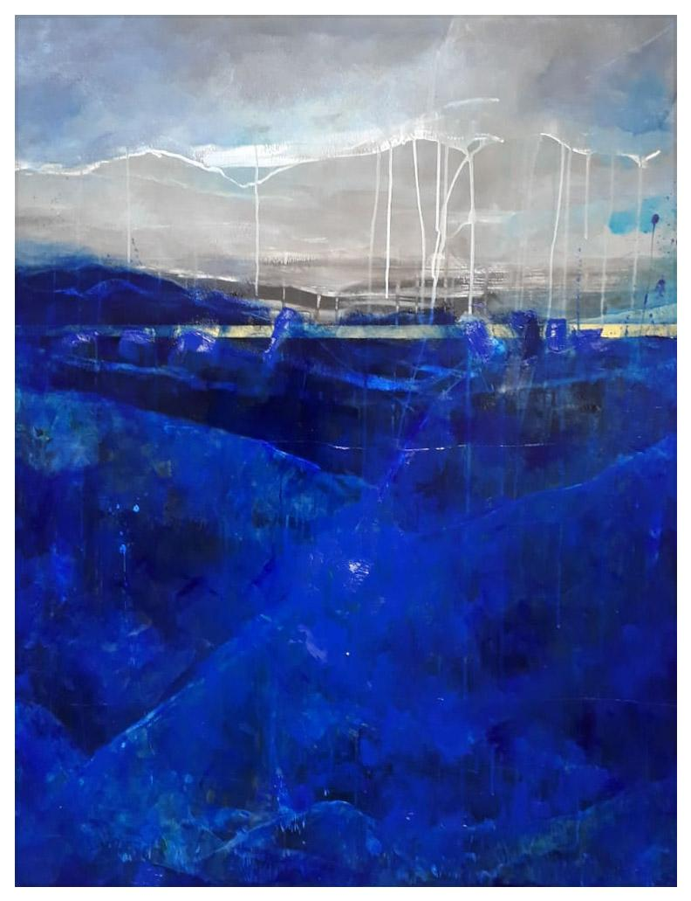
Photo 1. Untitled, 140/100, oil on canvas, 2019, Collection of Arkaabat Municipality, Trabzon, Turkey.

Covidie or Object n.ro 43, assemblage made of mixed media, 2020.
Object nr.43 or Covidie (Photo 2,3,4)is an assemblage made offroma ready made object, a cage and polyurethane foam and acrylic pigment. Its concept has been developed during the first month of lockdown due to Covid 19 pandemia. The term”Covidie” is a (made up) word created by taking the romanian word colivie which means cagein English and changing two letters in order to have the word covid integrated(se paote formula mai direct). This causes an intermingling of phonetic objects in the title of the artwork. The other title refers to my series of assemblies that I started in 2017. Assemblies are a series of objects. They are located on the border between painting and sculpture. Due to the specific support of the painting, the positioning within the exhibition space on the wall and the use to even out the color fields, they can be considered apictorial assemblies. Conceptually, they can be framed(characterized as an?)in impossible objects, but not in undecided ones such as those(the sense)of the Swedish artist Oscar Reutersvard or the Dutch M.C. Escher. The impossible objects theyReutersvard and Escherrefer to are those defined by the phenomenologist Alexius Meinong. They are imaginary objects such as a square or a mountain of gold. The title of the assemblies contains the word object (ex: Object no. 01). This word defines everything around us, real or unreal, constructed, non-existent, fused. The number received is like a chronological classification number. Each object, regardless of its nature, is (also)chronological in my creation. This feature of the title can give the series a personal diary feature, showing the chronological approach of developing the layers of concepts superimposed over the personal daily experience. The third element of the title, if present, refers to the nature of the integrated object. Although the integrated object is an object itself, it goes through recontextualization to the category of impossible object with accents of object of chance: the phonetic object, chromatic object, social object, absent object.
It was shown public for the first time in the Annual Winter Salon of the Artist Union, Timișoara (UAP Timișoara) in an online exhibition. After that it was also integrated in the online exhibition „21 EXPRESSIONS” organized by Faculty of Fine Art ASWARA Malaysia and ArtFort India, curated by Prof. Suzlee. The exhibited medium, the online gallery space, is deeply connected with the concept of the artworks, it`s iconologic layer. Because of the forced isolation that happened starting with the month of March, year 2020, the condition of the visual artist was damaged by not having any wayspossibilityof travelling possibilities and also no events in which to complete the artwork by the intervention of the viewer.

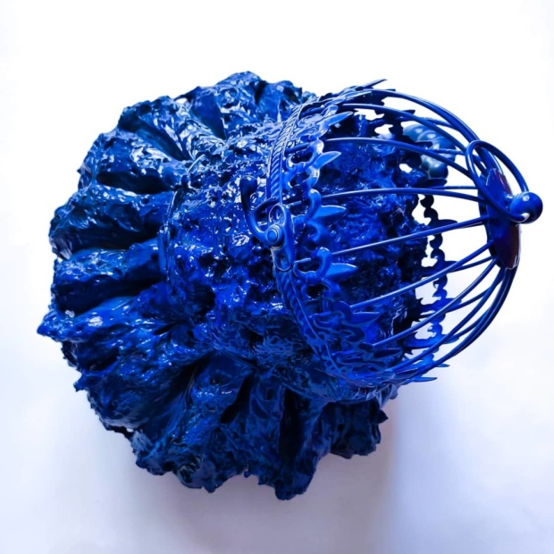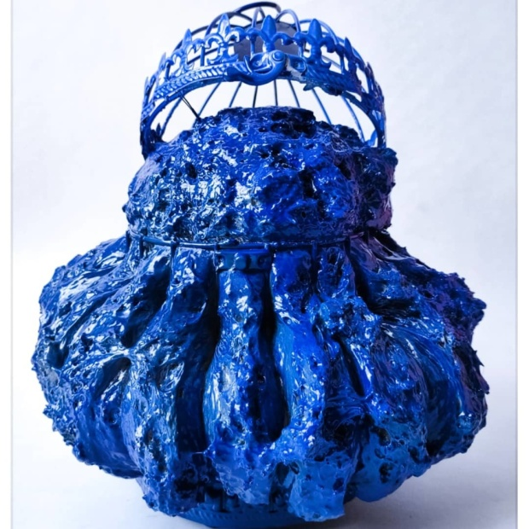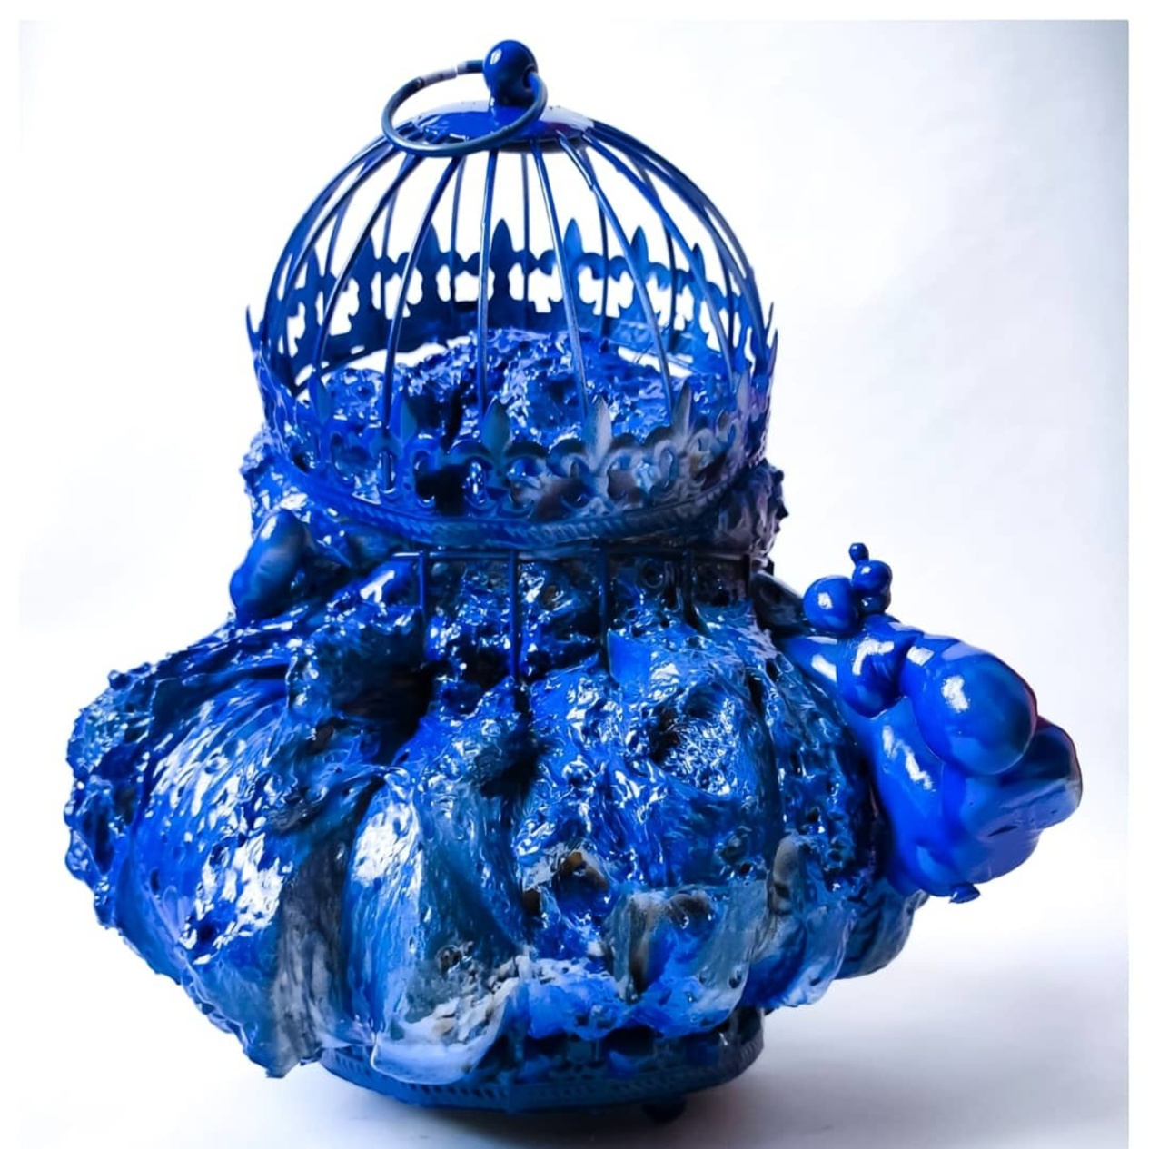
Photo 2,3,4. Object nr.43 or Covidie, assemblage, 2020.

Results. An interflow of blue

As a result not only this situation concludes in the first case in a painted conflict between nature itself and the human mind. This kind of conflict representation can, of course, take on different functions in varying social contexts, being a much more deeper theme of the conscious collective in our days. In the second case,With intervention of memory and other specific elements inspired by phonetic dada objects in the title, ready-made objects lead to a tridimensional representation of a contradiction that involves a time disruption. The assembly that contains the actual object loses its daily, real load and travels(shapes?) on the time axis a foray into another moment, still part remaining the anchor in the present. The present (situation?) is the feeling of emptiness, loneliness, uncertainty and captivity, a feeling we have all felt in the last year because of the pandemic. The restrictions took us away from nature and prevented us from traveling. The only possible journey is one that involves imagination, memory. This mixture of then and now is possible by recalling the feeling of freedom and rendering it through the color blue of the cage and its expansive form.

The two works, one in traditional painting and one in an experimental technique, one two-dimensional and one three-dimensional, support their emotional load in antithesis, but are unified at the same time by the interflow of color. In both studies there are both everyday elements of life in opposition to the most special ones, which take us out of the routine, such as travel, crossing borders and meeting new cultures and places.

Discussions
The present research falls within the interdisciplinary and transdisciplinary area by appealing to different adjacent domains. Its importance is closely related to the development of the area of ​​visual creation in object painting, assembly and color theory through unification processes. Exploring themes such as memory, wandering thoughts and deviating from the norms of traditional painting become like a Dadaist gesture. The gestures are extracted from micro adventures from other lands and recomposed in painting and object painting. The recollection of actions such as walking and interacting with nature or withthe urban landscape of a space other than the local one is distinguished as a ritual of recomposing memory. Travel research of certain spaces is absolutely necessary. An action-reaction dialogue is created between the situations encountered in other spaces, culture and local traditions, most often documented in the first stage through photographs.
Dadaism contains a wide area of ​​research of the object that develops through the prism of its ideology. It is a movement full of contradictions, where the principle of contradiction being the basis of its ideology. However, we can say that the element of provoking confusion is just a pretext to provoke and rebel, so that in the end a simple question can be reached: Where will art go? It is a unification of oppositions, chance and artistic individuality.

Conclusion
The object in painting interpreted transciplinarily across the philosophical theories of Plato, Artistotel, Ayers, Lewis, Smith folds on the concepts of modern artists, especially those from the incipient period of modern art, located somewhere at the beginning of the first stages of Cubism.
The mentioned metaphysics is the one that derives from Plato's writings, where the distinction between the two realities occurs: the intelligible world and the world of ideas. The world of intelligible objects is the shadow of objects as ideas, entities, substances. Objects are, on the one hand, entity objects or objects themselves. The latter represents the everyday symbols of the middle class concerned with utilitarianism, which then become ideas, concepts, they want to highlight a return to simplicity, unity, integrity and harmony through compound geometric shapes closer and closer to the basics. The world seen through the prism of classicism is a rigorous suite of objects, ordered independently of the subject. This direction towards the renaissance ideals is not fully supported, because the imperfection intervenes, which derives from the anamnesis of the ego in the attempt to acquire specific values ​​such as originality and novelty. But even these values ​​do not remain pure in the personal framework, of the self, they become perhaps less original through the seriality of the works, being only slightly different from each other. There is a dichotomy between order and disorder, austerity and gesturalism, geometric and organic,
During the stages of the observation of the three-dimensional space and the conception of the pictorial space (through the visual, tactile perception) a bridge is mould between consciousness (imagination) and matter. Art and philosophy melt together and become one.

Observații: Acest text propune de la început o analiză cu caracter științific. Promite că analizează din mai multe puncte de vedere/perspective ce înseamnă obiectul sau obiectul în arta contemporană însănu duce la îndeplinire acest lucru. Exemplele sunt puține, răsfirate, fără studii de caz, împrăștiate cronologic, împrăștiate la nivel de școală de gândire. Nici un studiu de caz din arta contemporană. E o trecere bruscă de la o analiză obiectivă, bazată pe o bibliografie, la o analiză extrem de subiectivă, cu iz poetic, la păreri despre condiția artistului pe timpul pandemiei. Dacă artiștii au migrat în zona virtuală de reprezentare și expunere, ar fi trebuit analizat ce înseamnă ”obiectul digital”, etc. Analiza obiectului e abandonată total în ultimile două treimi ale acestui text.

Bibliography

Aristotel. 2007. Metafizica. Edited by Andrei Cornea. București: Humanitas.
Ayers, Alfred. 2005. Sensory integration and the child. Los Angeles: Western Psychological Services.
Brentano, Franz. 1973. Psychology from an Empirical Standpoint. London: Routledge.
Gross, Stephen. 1994. Holes and other superficialities, Introduction. N.p.: MIT Press.
Harlan, Volker. 2003. Ce este arta? Discuție - Atelier cu Joseph Beuys. Cluj: ed. Idea & Design Print.
Lewis, David, and Stephanie Lewis. 2006. “Holes.” Australasian Journal of Philosophy 48, no. 2 (september): 206-212. http://dx.doi.org/10.1080/00048407012341181.
LeWitt, Sol. 1967. “Paragraphs on Conceptual Art.” Artforum, 1967.
Lugli, Adalgisa. 2000. Assemblage. N.p.: Adam Biro.
Marek, Johann. 2021. “Alexius Meinong.”The Stanford Encyclopedia of Philosophy, (spring edition). <https://plato.stanford.edu/archives/spr2019/entries/meinong/>.
Russel, Bernard. 2004. Problemele filosofiei. București: All.
Smith, Barry. 2001. Fiat Objects. Netherlands: Kluwer Academic Publishers.

