MARIA-LUISA ŢUCULEANU
«George Enescu» National University of Arts Iaşi

Drama as a form of visual arts in Eugène Ionesco’s play The Chairs
Abstract
This study explores the relationship between visual arts and theatre in Eugène Ionesco’s work, mainly in the play The Chairs. By researching the connection between the two domains of activity it becomes evident that the multiplication of chairs in the play, for instance, resembles an authentic artistic installation. Furthermore, objects are of great importance in Ionesco’s theatre to the prejudice of words, as is the case with Pop art movement (the traditional means of expression are entirely replaced by ordinary objects). Thus, the distance between art and life is narrowed and the object’s serial production refers to a new way of living and creating. All in all, theatre is a form of performing art, as both domains, one theatrical, the other one pertaining to visual arts, open up multiple possibilities for the analysis of the present essay.

Keywords: chairs, objects, language, communication, artistic installation, everydayness, absence

The aim of this paper is to underline the connection between two different domains, namely visual arts and theatre, in Eugène Ionesco’s work, from the perspective of a typical artistic and dramatic vision. In this essay, we have selected a few references from the play The Chairs, which thoroughly provides an overview and offers a fruitful reading of several concepts specific to the dramatic poetry and the artistic language at the same time. In this context, we shall emphasize the fact that appropriate attention should be given to contemporary art, particularly to some art forms, such as happening, performance, installations etc.
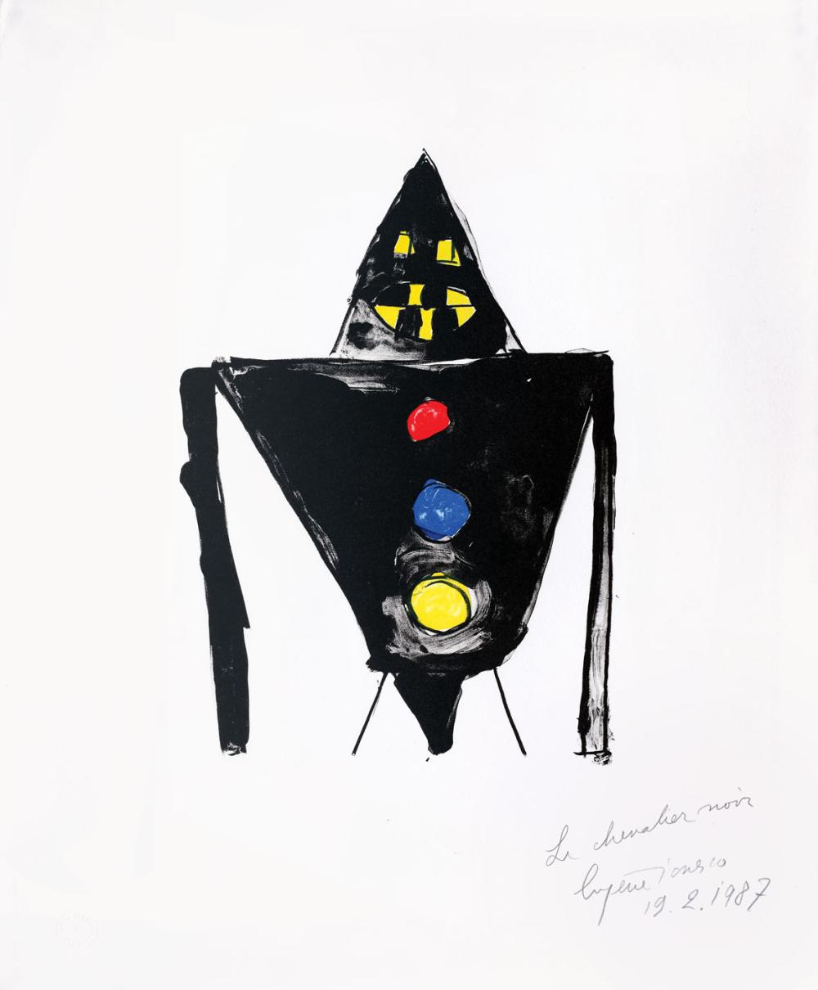
Eugène Ionesco, The Black Knight, 1987

The visual arts’ influence in Eugène Ionesco’s work is not a topic which has been much studied. However, the article attempts to point out a few guide marks beginning with the analysis of the objects in general and their importance in the economy of Ionesco’s theatre, in comparison with some artistic elements, as well as their implications considered from a different perspective, namely that of a painter. Having this very aspect in view, we shall be mindful of the author’s concern with the activity of painting and realizing lithographs in bright and bold colours. First of all, we should mention that he rejects conventional forms. We must not forget that the Romanian-French author is known for his innovative techniques, being an avant-garde dramatist. On the other hand, as a painter, he creates a dehumanized world, with strange characters consisting of geometrical structures, rigid lines and sharp angles. Typical of the artist, the black outline is aggressive and quite provocative, suggesting a metallic, heavy structure similar to that of a machinery. In a way, The Black Knight (see the image above) bears resemblance to an artistic installation.
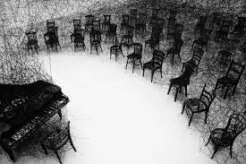
Shiota Chiharu, In Silence, Mori Art Museum, Tokyo, 2008

It is interesting to note that installations, for instance, mean experiencing art in a new way, as displaying a great number of chairs on the stage could highlight their multiplication as a manner of undermining the human’s presence (the work of the Japanese artist Shiota Chiharu who realizes an installation consisting of a piano and a lot of chairs covered by black wool threads is relevant from this point of view). In fact, the ordinary object having a life of its own aims to replace the actor in theatre, respectively the artist’s status, becoming the main subject of the play or artwork. The chairs stand out indeed in Ionesco’s play (in a repetitive and circular gesture) as objects do in Pop art movement. Hence, the distance between art and life is narrowed by having in the centre of attention mass-produced objects from daily life. However, installation art/happening can be found in galleries, as well as in public areas, that is why there may be a great chance to identify it on the stage too, offering the audience the real feeling of participation. In fact, happenings are theatrical events, including lights, sounds etc. Similarly, performance art, including happening, attempts to define another alternative for the artistic act, sketching out actions performed by artists. Eventually, they turn out to be real actors. It seems that there is no barrier between actor and performer, as acting is the performing art, where music, gesture and dance are in perfect agreement with each other. This is how art relates to theatre.
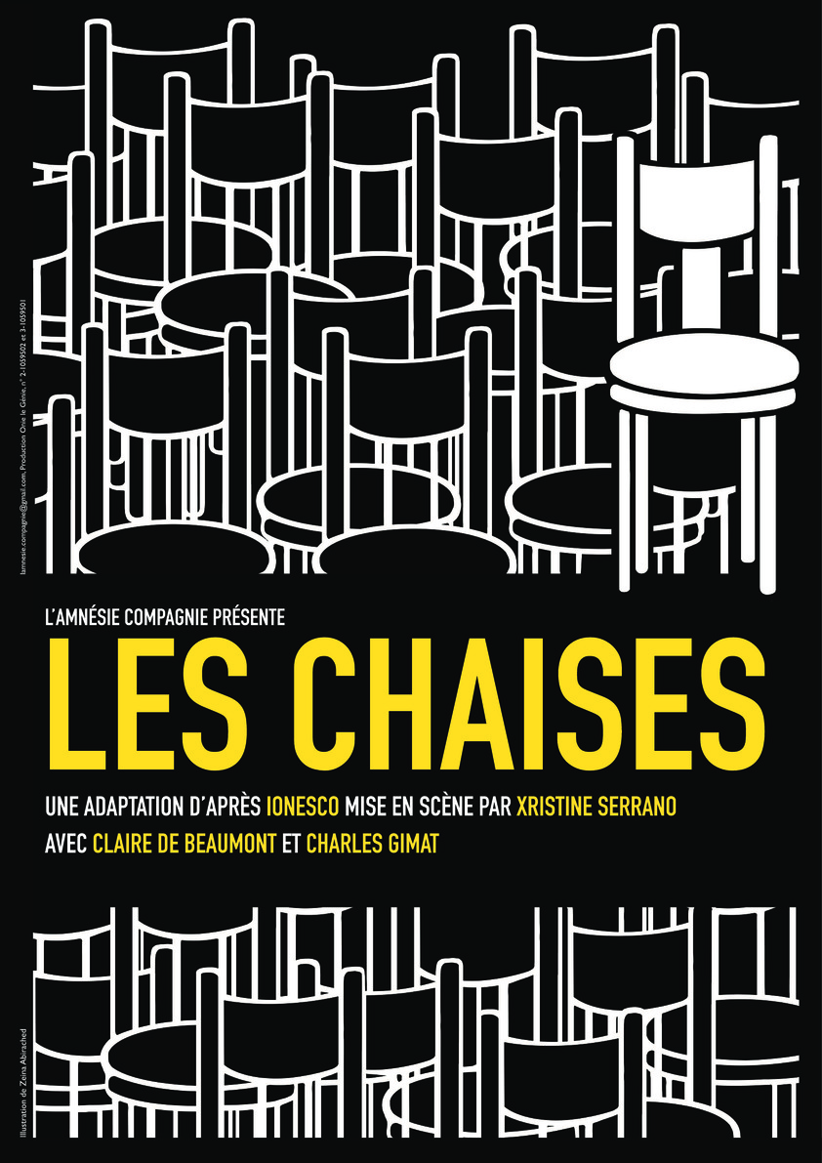
The Chairs, Théâtre du Fil à plomb, 6-9 February 2019

To take another example, there is the issue of Pop art, which tends to be anonymous. Pop artists’ interest in objects (widely possessed by ordinary people) leads to the idea of using objects on the stage in the same conceptual manner. We can argue, by comparison, that Ionesco’s proposition of exposing on the stage a lot of overwhelming things, such as the well known chairs prepared for a series of invisible guests, suggests the very general concept of absence, the missing character of the scene, as well as the idea of conformity and sameness, seen as a key notion for the entire reading of the play The Chairs. Consequently, the chairs turn out to be the central character, so the title of the play essentially makes sense. In the opinion of Stanton B.Garner, they actually dramatize a game of absence and presence orchestrated through the intermediacy of objects. The author even suggests in his book Bodied Spaces: Phenomenology and Performance in Contemporary Drama a Freudian reading of the play. The issue is reinforced in the play’s text by references of the Old Man to maternal absence.

Th

As closer examination of this play illustrates, the mise-en scène of their increasing number may also create a sense of menace and alienation in a chaotic world that accumulates objects in a frenetic way. The object’s serial production refers to the idea of capturing the meaninglessness of existence due to the consumer society way of living. According to Cambridge Dictionary, «consumer society» refers to a society in which people often buy new goods, and that places a high value on owning things. Therefore, possessing goods reflects people’s ideal in a modern world of abundance, which virtually destroys individuality. The consumption on a large scale is thus encouraged and mass media culture has a say in this matter. Regarding this very aspect, the French sociologist and philosopher Jean Baudrillard analyses our contemporary societies in his book The Consumer Society, focusing on the consumption of objects, which shape a new mythology. It worth mentioning the fact that objects are no longer associated with a specific function as they used to, being guided by a certain logic of desire. In this light, the idea of kitsch should be discussed. For example, Baudrillard argues that this very notion defines pseudo-objects through the method of imitating and repeating. Once again, then, the idea of individuality and creativity fully disappears, as the real cause lies in the act of producing in an excessive manner, as is the case with Pop art movement. Indeed, art has stopped to be creative in a certain sense.
A brief glance at Ionesco’s play suggests the affinity between the consumerism’ principles and Pop art’s aesthetics, that fit well within his plays dominated by irony, paradoxes, clichés, and sarcasm. In other words, this is key to understanding the play The Chairs: the idea of abundance, given the fact that it explores the paradoxical status of the character through the multiplication of an ordinary object. More specifically, Ionesco paints a picture of a secluded character on the whole, in spite of the fact that the Old Man and Old Woman are surrounded by usual, proliferating objects. In this light, the idea of everydayness, as Baudrillard would say, fundamentally reflects the central message of The Chairs. Hence, the paradox of growth stresses the very idea of solitude and lack of communication, despite the continuous talking (the Old Man and Old Woman converse with each other by saying nothing in the end). In this reference to language, their words are incomprehensible. Ironically, they appear as an impossible means of communication. That is why objects are to a certain extent the character’s key to communication. Finally, the mechanical movement of the chairs reminds the audience of the distortion of speeches, as well as their endless repetitions and incoherence in a world that lacks cohesion.
In conclusion, this very connection between objects and words is emblematic of the comparative analysis (visual arts versus theatre) in the present paper. As far as (contemporary) visual arts are concerned, objects tend to replace specific elements of language, while the characters’ speech in The Chairs seems to be replaced by another type of language, consisting of discontinuities, fragmented words, clichés, sounds, and last but not least the metaphorical game of chairs. All in all, the comparison between arts and theatre opens up multiple possibilities for interpreting a play's lines, as is the case with The Chairs.

Bibliography

Ionesco, Eugène, 1991, Théâtre complet, édition présentée, établie et annotée par Emmanuel Jacquart, Paris, Gallimard.
Ionesco, Eugène, 1996, Entre la vie et le rêve (Entretiens avec Claude Bonnefoy), Paris, Gallimard, Collection Blanche.
***
Baudrillard, Jean, 2016, The Consumer Society: Myths and Structures, Sage Publications.
Deshoulières, Christophe, 1989, Le théâtre au XXe siècle, Paris, Bordas.
Kowzan, Tadeusz, 1992, Sémiologie du théâtre, Éditions Nathan.
Lazar, Moshe, 1982, The Dream and the Play. Ionesco’s Theatrical Quest, Undena Publications.
Stanton B.Garner, 1994, Bodied Spaces: Phenomenology and Performance in Contemporary Drama, Cornell University Press Ithaca and London.
Ubersfeld, Anne, 1978, Lire le théâtre, Éditions Sociales.
Vernois, Paul, 1991, La dynamique théâtrale d’Eugène Ionesco, Paris, Klincksieck.

https://www.britannica.com/art/Pop-art, accessed the 12th of May 2021
https://dictionary.cambridge.org, accessed the 19th of May 2021.

https://www.tate.org.uk/art/art-terms/h/happening, accessed the 19th of May 2021.

Stanton B. Garner, Bodied Spaces: Phenomenology in Contemporary Drama, Cornell University Press Itacha and London, 1994.
https://dictionary.cambridge.org, accessed 19.05.2021.
Jean Baudrillard, The Consumer Society: Myths and Structures, Sage Publications, 2016.

